

NAME : BISMA FATIMA
CLASS : CS A
ROLL NO: F24605036
COURSE : DATA STRUCTURE
COURSE CODE : CS-211
LECTURER : SIR MEHRAN YOUSAF

LAB TASK 01

TASKS
Task 1: Generate All Pairs
Description: Write a C++ function that takes two separate integer vectors, vec1 and vec2, and prints all possible pairs of elements, with one element from each vector. For example, if vec1 = {1, 2} and vec2 = {A, B}, it should print 1A, 1B, 2A, 2B.
Function Signature:
void generatePairs(const std::vector<int>& vec1, const std::vector<char>& vec2);

Hint: Think about what kind of loop structure you would need to visit every element in vec1 paired with every element in vec2. Let the size of vec1 be m and the size of vec2 be n.

PROGRAM
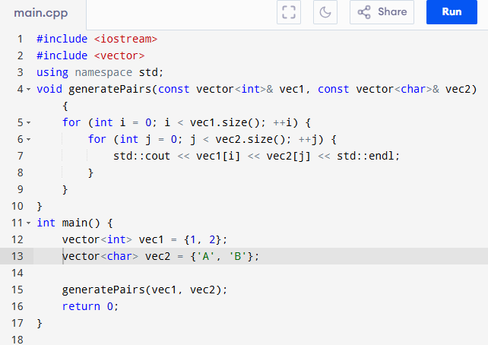

OUTPUT
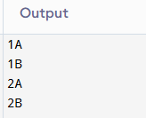
Analysis Walkthrough:
● Time Complexity Analysis:
- Suppose vec1 has size m, and vec2 has size n.
- We loop through each element in vec1 → this gives m iterations.
- For each element in vec1, we loop through all elements in vec2 → n iterations per element.
- Inside the inner loop, we perform a constant-time operation (e.g., printing the pair).
- So, total operations = m * n constant-time operations.
- Final Time Complexity: O(m * n) — Quadratic Time in terms of input sizes.
● Space Complexity Analysis:
- We are not using any extra space except for loop variables.
- Input vectors are passed by reference — not copied.
- We only use a fixed amount of space regardless of input size.
- Final Space Complexity: O(1) — Constant Space.

Task 2: Find the Common Elements
Description: Write a C++ function that takes two integer vectors and returns a new vector containing only the elements that are present in both input vectors. Do not worry about duplicates in the output.
Function Signature:
std::vector<int> findCommonElements(const std::vector<int>& vec1, const std::vector<int>& vec2);

Hint: You’ll likely need to compare every element from the first vector against every element in the second. How does the space complexity change since you are now creating a new vector for the result?

PROGRAM

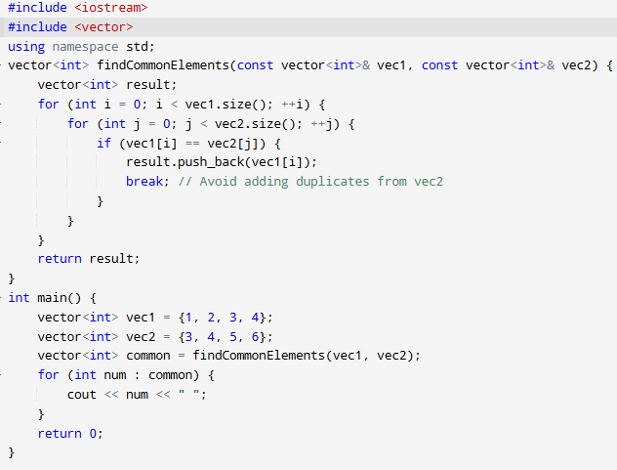

OUTPUT

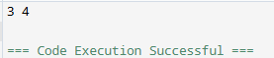
Analysis Walkthrough:
● Time Complexity Analysis:
Naive Approach:
- For each element in vec1 (size = m), compare it with every element in vec2 (size = n).
- That’s m * n comparisons.
- Final Time Complexity (Naive): O(m * n)
Optimized Approach (Using Hash Set):
- Insert all elements of one vector into a hash set → O(n) or O(m) depending on which vector you choose.
- Loop through the other vector and check for existence in the set → O(m) or O(n).
- Overall Time Complexity: O(m + n) (Linear in combined input size)
● Space Complexity Analysis:
- We create a hash set to store one of the input vectors → up to O(n).
- We also create a result vector for common elements → worst case O(min(m, n)).
- So overall, auxiliary space is linear.
- Final Space Complexity: O(m + n)

Task 3: Check for Palindrome
Description: A palindrome is a word or phrase that reads the same forwards and backwards (e.g., "madam", "racecar"). Write a function that checks if a given string is a palindrome.
Function Signature:
bool isPalindrome(const std::string& text);

Hint: You can solve this by comparing characters from the beginning and end of the string, moving inwards. How many times will your loop run relative to the length of the string, n?

PROGRAM

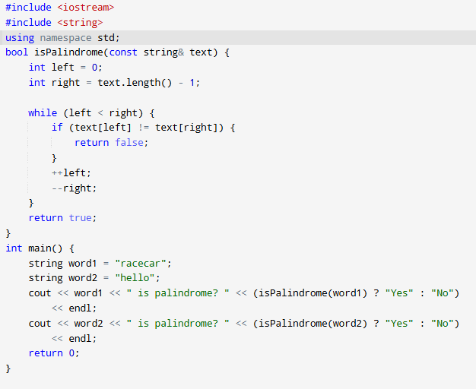

OUTPUT

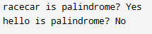
Analysis Walkthrough:
● Time Complexity Analysis:
- We compare the first and last characters and move inward.
- We only need to iterate through half the string.
- So, for string of length n, we do about n / 2 operations.
- In Big O, we drop constants → Final Time Complexity: O(n)
● Space Complexity Analysis:
- We use two index variables to traverse the string.
- No additional space used other than these variables.
- Final Space Complexity: O(1) — Constant Space.

Task 4 : The Dominant Element
Description: An element is "dominant" if it appears more than n/2 times in an array of size n. Write a function that finds the dominant element in a vector. If no such element exists, return -1 (or any other indicator).
Function Signature:
int findDominantElement(const std::vector<int>& arr);
Challenge: A naive solution would be O(n^2) (comparing every element with every other). Can you think of a solution that is better than O(n^2)? Maybe one that is O(n)? This is a tricky one that requires clever thinking about space and time trade-offs.

PROGRAM

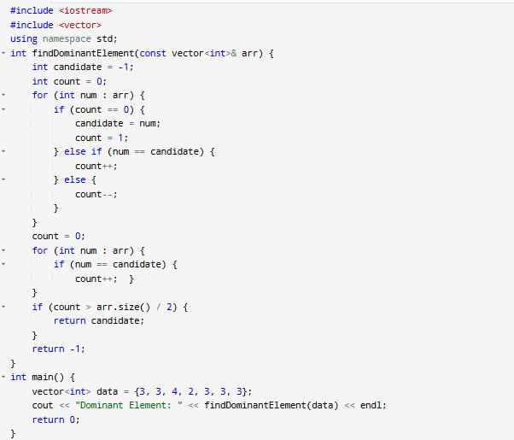
OUTPUT

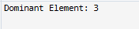
Analysis Walkthrough:
● Time Complexity Analysis:
Naive Approach:
- For each element, count how many times it appears (loop inside loop).
- That’s O(n^2) — inefficient for large arrays.
Optimized Approach (Using Hash Map):
- Traverse the array once, storing counts in a hash map → O(n)
- Traverse the map or track max count during the first pass → still O(n)
- Final Time Complexity: O(n) — Linear Time
● Space Complexity Analysis:
With Hash Map:
- We store up to n unique elements → O(n)
With Boyer-Moore:
- Only a few variables: candidate and count.
- Final Space Complexity: O(1) — Constant Space

